Important Advice from our insurers on war and high-risk territories, including the Global Cargo Watch List (GCWL), War cover and cover ending from the start of unloading at port of discharge in high-risk territories
War cover ONLY attaches whilst on the vessel/aircraft; there is no war cover whilst on land, or whilst on any carrying conveyance at the final port or place of discharge
Excluded and/or Restricted Countries or Territories
This insurance does not cover subject-matter insured cargo during any transit to, from or via and any transit or storage within:
- Afghanistan, Belarus, Cuba, Iran, Iraq, North Korea, Russian Federation, Sudan, Syria, Ukraine;
- any country in which imports or exports are required to be insured in that country and cover under this insurance would be illegal, other than to the extent that the Policyholder's contingent financial interest is protected by the cover provided by this insurance;
- any country or territory with a very high, severe or extreme risk, having a scale value of 3.2 and above on the Global Cargo Watch List (GCWL). Please see www.munichre.com/mrsiuk/war-strikes-updates
Despite the provisions of this clause, this insurance covers the subject-matter insured during any transit which is undertaken via Belarus and/or the Russian Federation.
But if Belarus or the Russian Federation is a very high, severe or extreme risk, with a scale value of 3.2 or above on the Global Cargo Watch List (GCWL), this insurance will not cover the subject matter insured during any transit undertaken via these territories.
When this insurance does cover transits to:
Brazil, Central African Republic, Lebanon, Libya, Mali, Mexico, Qatar, Somalia, South Sudan, Venezuela or Yemen.

There is no cover provided for subject-matter insured following:
- in respect of transit by sea or waterway, completion of unloading from the vessel onto either the quay or waiting conveyance at the port of entry;
- in respect of transit by air, completion of unloading from the aircraft onto the ground or waiting conveyance at the airport of entry;
- in respect of transit by land, crossing of the border;
into the country concerned.
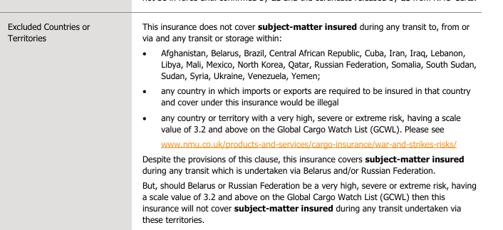
https://www.munichre.com/specialty/global-markets-uk/en/solutions/cargo-insurance/war-strikes-updates.html
https://watchlists.spglobal.com/watchlists-viewer-public
REMINDER:
YOU MUST CHECK THE GCWL LIST AND EXCLUDE FROM QUOTING TO/FROM ANY TERRITORY AT 3.2 VALUE SCALE (VERY HIGH RISK) AND ABOVE.

